UJIAN MSQL

NO 1.

mysql> select * from city where CountryCode="IDN" order by population desc limit 10;

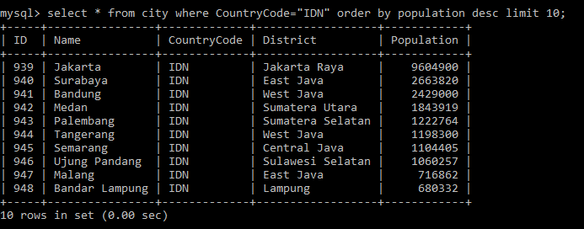

NO 2.

mysql> select city.id, city.name as "nama_kota", city.district, country.name as "Negara", city.population

-> from city, country

-> where city.countrycode=country.code

-> order by city.population desc

-> limit 10;

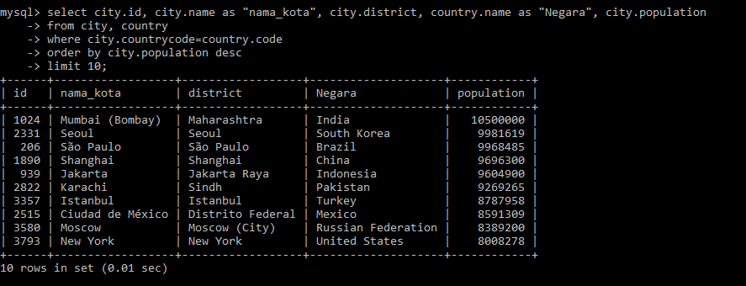

NO 3.

mysql> select Code, Name, Continent, Region, IndepYear as "Tahun_Merdeka" from country where not indepyear="null" order by indepyear limit 10;

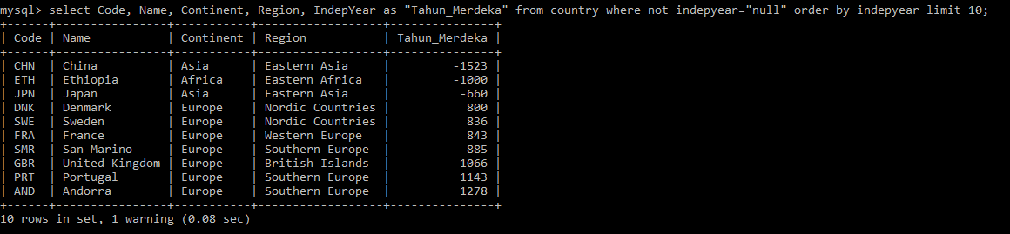

NO 4.

mysql> select continent as "Benua", count(name) as "Jumlah_Negara", sum(Population) as "Populasi", avg(lifeexpectancy) as "Rata_AngkaHrpnHdp" from country where not population=0 group by continent order by sum(population) desc;

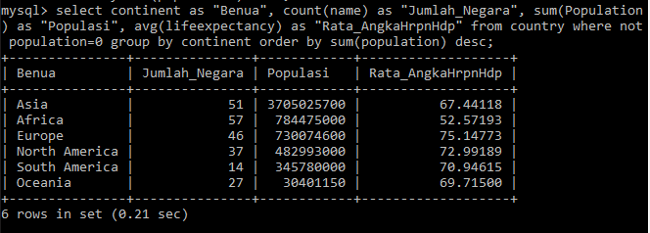

NO 5.

mysql> select name as "Nama", continent as "Benua", lifeexpectancy as "AngkaHarapanHidup", gnp

-> from country

-> where continent="Asia"

-> order by lifeexpectancy desc

-> limit 10;

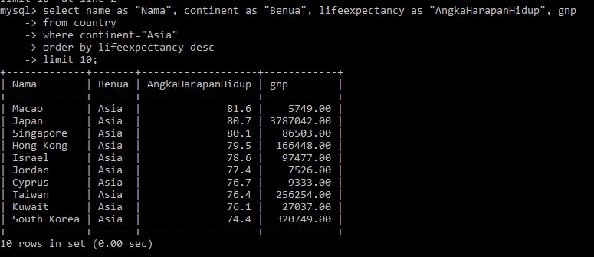

NO. 6

mysql> select countrylanguage.countrycode, country.name, countrylanguage.language, countrylanguage.isofficial, countrylanguage.percentage

-> from countrylanguage, country

-> where countrylanguage.countrycode=country.code

-> and countrylanguage.language="English"

-> order by countrylanguage.percentage desc

-> limit 10;

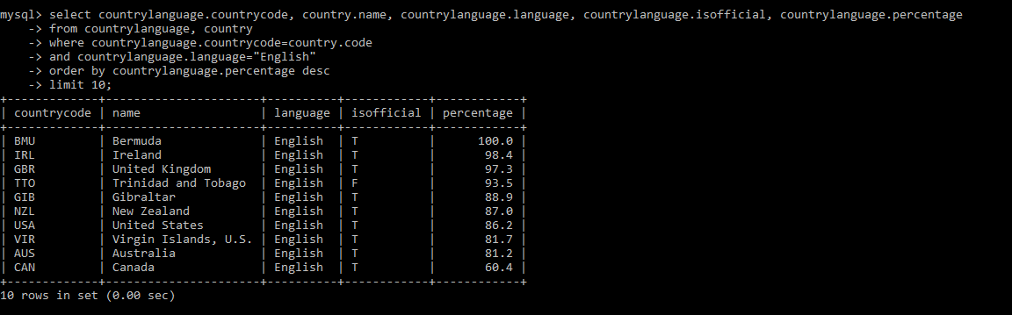

NO. 7

mysql> select country.name as "NegaraASEAN",

-> country.Population as "PopulasiNegara",

-> country.gnp,

-> city.name as "Ibukota",

-> city.population as "PopulasiIbukota"

-> from country, city

-> where country.capital=city.id

-> and country.region="southeast asia"

-> order by country.name;

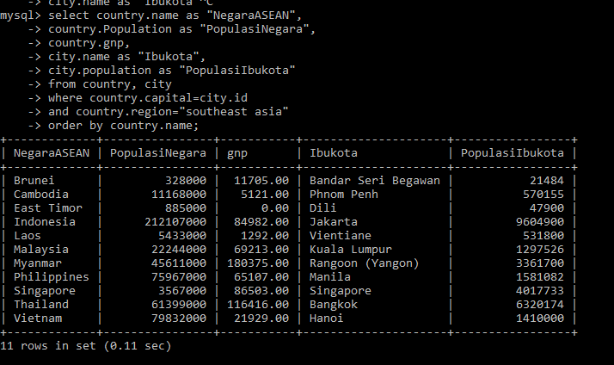

NO. 8

mysql> select country.name as "Negara_G20", country.population as "Populasi_Negara", country.GNP as GNP,

-> city.name as "Ibukota", city.population as "Populasi_Ibukota"

-> from country, city

-> where country.name in ("argentina", "australia", "brazil", "canada", 'france', 'germany', 'india', 'indonesia', 'japan', 'mexico', 'russian federation', 'saudi arabia', 'south africa', 'south korea', 'turkey', 'united kingdom', 'united states', 'italy')

-> and country.capital=city.id

-> order by country.name;

